This document provides a comprehensive overview of the Awesome-Deep-Learning-For-Machine-Vision repository, which contains a collection of optimized machine vision approaches using deep learning techniques. The repository features three main projects focused on different aspects of machine vision: human action recognition, object tracking, and bio-inspired image recognition. This overview page introduces the repository structure, summarizes each main component, and illustrates how these systems relate to each other.

**Repository Overview**

The Awesome-Deep-Learning-For-Machine-Vision repository is a collection of deep learning-based machine vision approaches. Some components are reproductions of existing GitHub repositories, while others are novel implementations still under academic evaluation. The repository is licensed under MIT, allowing for free use, modification, and distribution with proper attribution.

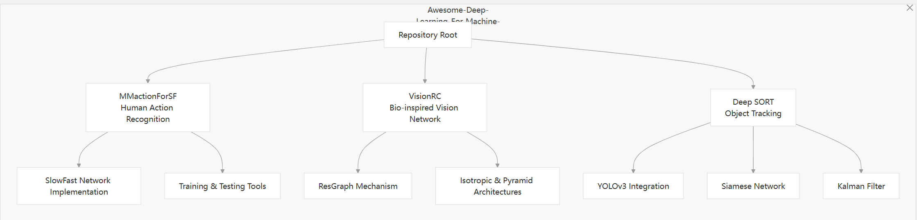

Figure1

The repository contains three primary systems, each focusing on different aspects of computer vision:

Table1

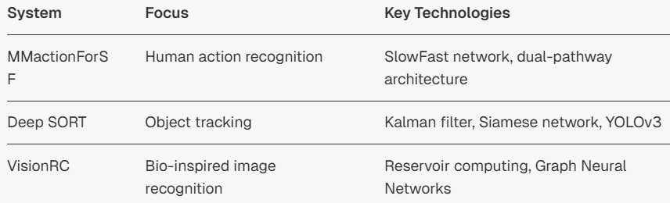

**Main Components**

**MMactionForSF**

MMactionForSF is a dual-stream spatiotemporal architecture that utilizes the SlowFast network for human action recognition. The system processes video inputs through two pathways:

* A Slow pathway that captures spatial details with high channel capacity but low temporal resolution
* A Fast pathway that captures motion information with high temporal resolution but lower channel capacity

This dual-pathway approach enables effective processing of both spatial and temporal information in videos, making it particularly suitable for human action recognition tasks.

**Deep SORT**

Deep SORT (Simple Online and Realtime Tracking with Deep Learning) enhances the original SORT tracking algorithm with deep learning approaches, particularly YOLOv3. The system combines:

Object detection using YOLOv3

Visual appearance features extracted via a Siamese network

Motion prediction using Kalman filtering

Data association techniques for matching detections to existing tracks

These enhancements improve tracking performance in complex environments with occlusions, similar-looking objects, and varying lighting conditions.

**VisionRC**

VisionRC is a bio-inspired network that combines Reservoir Computing (RC), Graph Neural Networks (GNN), and traditional deep learning approaches for image recognition. Key features include:

The ResGraph mechanism, which integrates reservoir computing with graph processing

Support for both isotropic (ViT-inspired) and pyramid (CNN-inspired) architectures

Bio-inspired computational principles that aim for efficient visual processing

This system represents a novel approach to machine vision that draws inspiration from biological visual systems.

**System Integration Potential**

While the three systems are implemented as separate projects, they could theoretically be integrated into a comprehensive machine vision pipeline. The following diagram illustrates this potential integration:

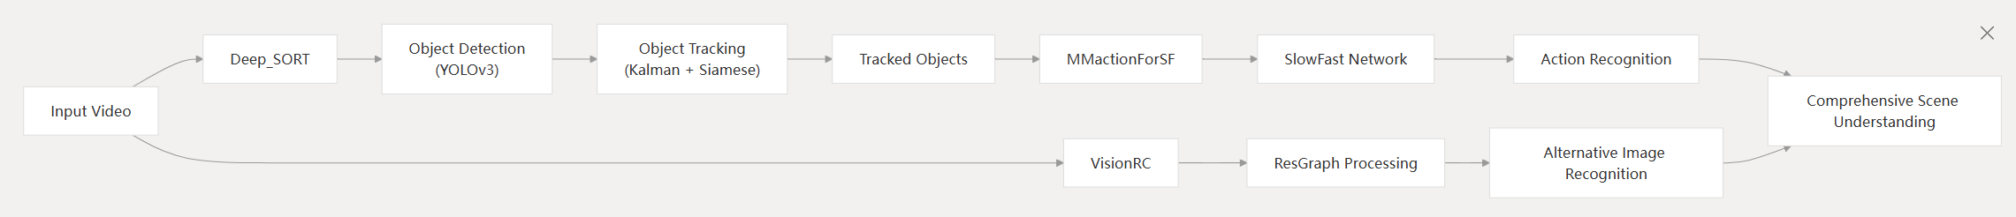

**Figure2**

In this potential integration:

1. Deep SORT would handle object detection and tracking in video streams
2. MMactionForSF would recognize actions performed by the tracked objects
3. VisionRC could provide an alternative pathway for image recognition

Such an integrated system would enable comprehensive scene understanding by combining object tracking, action recognition, and general image recognition capabilities.

**Code Organization**

The repository is organized into three main directories corresponding to the primary systems:

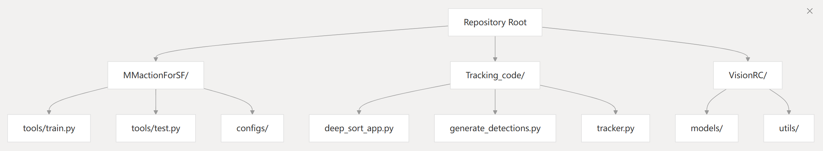

Figure3

Each system directory contains the implementation code, configuration files, and utilities needed to run the respective system. The repository follows a modular structure, allowing each system to be studied, used, or modified independently.